Jawaban No. 4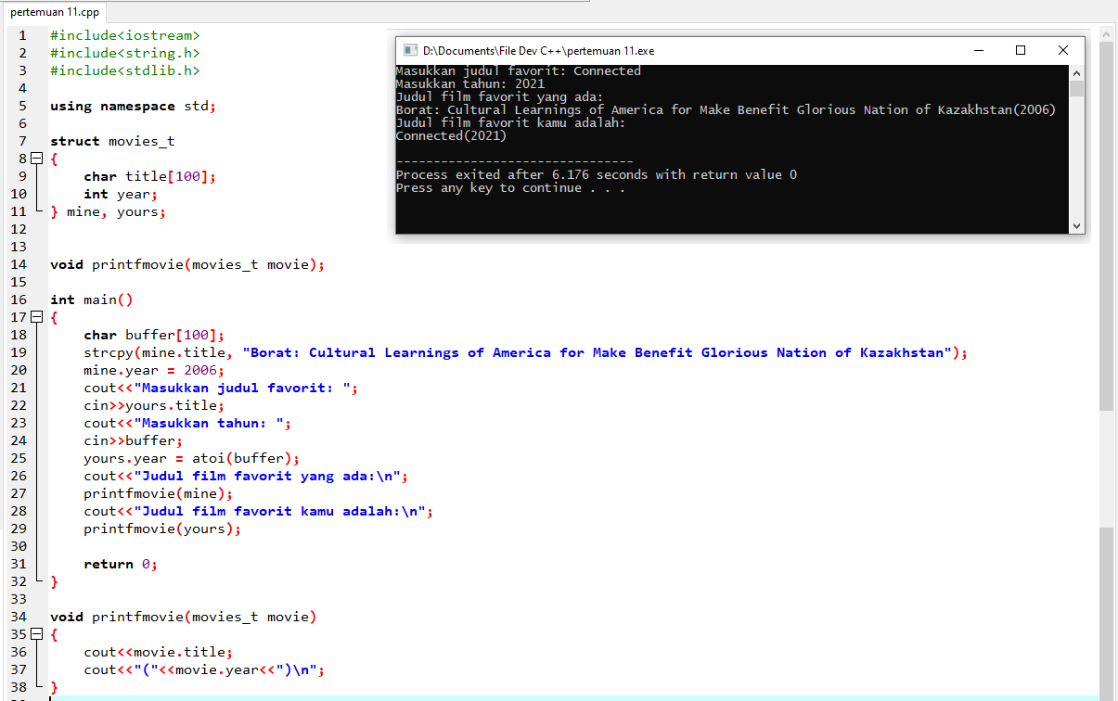**Source Code:**

#include<iostream>

#include<string.h>

#include<stdlib.h>

using namespace std;

struct movies_t

{

char title[100];

int year;

} mine, yours;

void printfmovie(movies_t movie);

int main()

{

char buffer[100];

strcpy(mine.title, "Borat: Cultural Learnings of America for Make Benefit Glorious Nation of Kazakhstan");

mine.year = 2006;

cout<<"Masukkan judul favorit: ";

cin>>yours.title;

cout<<"Masukkan tahun: ";

cin>>buffer;

yours.year = atoi(buffer);

cout<<"Judul film favorit yang ada:\n";

printfmovie(mine);

cout<<"Judul film favorit kamu adalah:\n";

printfmovie(yours);

return 0;

}

void printfmovie(movies_t movie)

{

cout<<movie.title;

cout<<"("<<movie.year<<")\n";

}